Research Compliance Onboarding and Rush Research Portal Training Registration Instructions
1 | Log into Rush using your Rush username and password
2 | Open Chrome or Edge and enter LearningHub.Rush.edu into the browser address bar  2
3 | On the Choose Portal, Rush is preselected. Click Submit  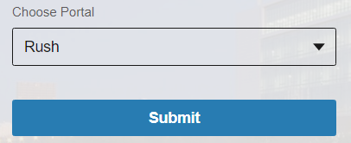  3
4 | After entering the Learning Hub, click Course Library  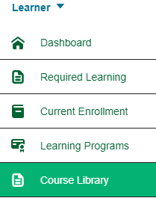  4
5 | In the Filter, type Research Compliance  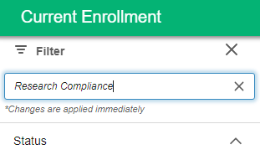  5
6 | Click the “Research Compliance Onboarding and Rush Research Portal Training” tile  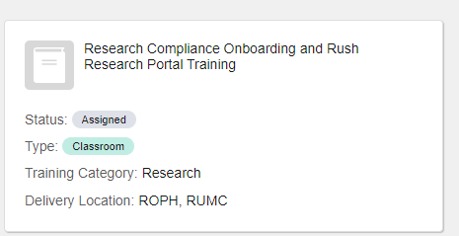  6
7 | Select the Friday, 10-12 noon session that you want to attend and click Register.  The course will register you. See the box in the upper right-hand corner.  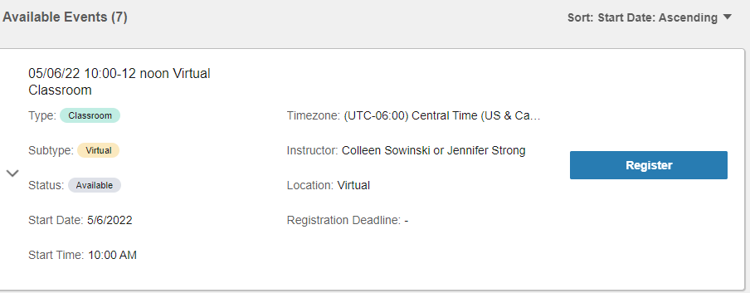  7
8 | Within an hour, you will receive an emailed Outlook Calendar invitation from the Learning Hub.  Accept the invitation.
9 | Open the invitation within your calendar. You will find information on registering for the required CITI Program training and information on registering for the OnCore Required Training.  - There is a link “here” to the training session to be utilized the day of the Research Compliance Onboarding and Rush Research Portal training.
10 | After the sessions are completed, go back to the Outlook Calendar Invitation and click on “Sign In Sheet Link”
11 | Complete the requested information which is needed to create your Rush Research Portal account
12 | After you complete the training:  - You will receive a Learning Hub Notification on the Monday following your training session.  - There are important documents for you to review embedded within the Notification.  - You will receive an email indicating your Portal account has been established when that process is completed.

Questions?
If you have questions, contact:
Colleen S. Sowinski at Colleen_S_Sowinski@rush.edu

If you have Portal questions, contact:
Antonio S. Demarco at Antonio_S_Demarco@rush.edu

